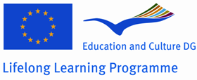
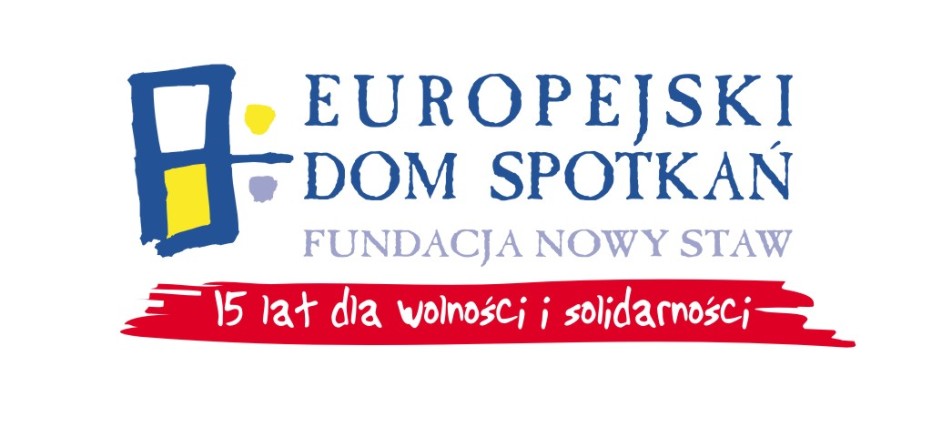
GRUNDTVIG
WORKSHOPS

LIFELONG LEARNING PROGRAMME
GRUNDTVIG
Information about the Workshop

“Creative juggling against routine in your life”

Juggling is becoming more and more popular among adults interested in developing their personal skills. Since the beginning of the 1980s, managers and employees of companies have been learning to juggle at seminars and workshops devoted to personal development, time management or project realization.

Juggling workshops function perfectly as a way of evoking and realizing creativity, internal potential, stress management, waking up inspiration, self-discovering and getting self-confidence.

Psychological research supports the thesis that juggling is beneficial for hand-eye co-ordination, sense of rhythm, reflexes, and also sense of balance and a proper posture of the body. Therefore, it is not surprising that psychologists increasingly often recommend juggling as a treatment in many dysfunctions and as a method in individual and group therapy for adults.

Objectives of the workshop:
Helping participants to learn new methods to overcome stress, routine and get new inspiration. It will be made mostly through juggling - method showing how we can overcome our barriers and limits and discover a child inside our minds, souls. Juggling skills seem impossible for ordinary people but practically everyone can master them. It shows us that we can do anything we want and desire. Beside juggling (different equipment), during the workshop participants will take part in different self-development exercises.

Date: 04.11.-09.11.2009. (arrival on 03.11. and departure on 10.11.)

Place: Nasutów (south-eastern Poland), in a beautiful region, close to the Landscape Park. The nearest big city is Lublin (16 km away from Nasutów)- the biggest city in the eastern part of Poland. It’s famous for the old city, castle, cathedral, numerous monuments, cosy restaurants, bars in various styles. The city has a long history of multiculturalism visible up to today.

Working Language: English

Trainer:
Psychologist, personal development trainer. Creator of „Juggling Inspiration Program”, which uses juggling in education and business and in which the psychological knowledge is used to get new abilities. He has a large experience in work with different age groups. He uses juggling as a perfect relaxing method, the metaphor of learning, of achieving success and picking up challenges.

Who can participate:
The project is directed to adult (from 18 years old) workers, family members, people who feel routine in their professional and private life. This is for those who want to change their life, feel tiredness, boredom, don’t know how to overcome the everyday problems, feel blocked with their new ideas. For those who feel that nothing can change in their life but at the same time they feel the strong need of changes, they need a new inspiration, new power. For those who want to re-discover their potential and give a new quality to their life.

Preferred are:
- applicants from: Spain, Great Britain, Ireland, Germany, Netherlands
- persons, who don’t have any experience in juggling
- immigrants

Decisive is moreover the order of supplying the applications.

How to apply:
Please fill in the enclosed application form and send it to us on following e-mail address: eds@eds-fundacja.pl.
Please send as well the application with your signature by mail (scanned), by fax or by post on the contact data below.
At the same time the application form should be sent to the National Agency in your country and to the National Agency in Poland.
The deadline for sending application forms is 19.10.2009.
We will give you respond concerning your participation until 21.10.2009.
With all classified participants we will contact individually by e-mail.

Participation costs:
The participation in the workshop is financed by the European Commission within the Grundtvig Programme. There is no participation fee. All workshop’s costs as well as the accommodation’s and full-board’s costs will be covered by the organizer.
Participants only have to buy tickets to Lublin and back. All travel costs (2nd class trains and busses, economic class for planes) will be fully reimbursed during the workshop (participants are requested to bring all invoices, tickets and boarding cards). We also ask you to tell us the price of your tickets before buying the tickets and to wait for our approval.

In the attachment you will find Program of the workshop and Registration Form.

Contact data:
Europejski Dom Spotkań – Fundacja Nowy Staw
Ul. Leszczyńskiego 14/1-3
20-069 Lublin / Poland

Tel. +4881 534 61 91
Fax. +4881 534 61 92
e-mail:eds@eds-fundacja.pl

Contact persons: Monika Doniek (m.doniek@eds-fundacja.pl), Marta Jędrych (m.jedrych@eds-fundacja.pl)

