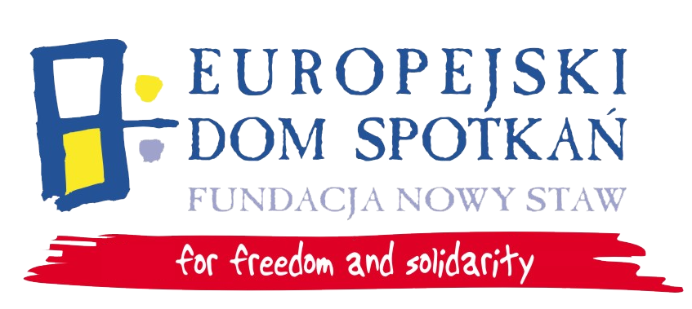

Social inclusion of young people
with fewer opportunities
7-15.05.2014 Nasutów near Lublin

PART 1 – Information on the applicant

A) Personal details

1. | First and last name:
2. | Date and place of birth:
3. | Female (F)/Male (M)
4. | Address and telephone number:
5. | Profession/occupation:
6. | Special needs (e.g. vegetarian dishes etc.):
7. | E-mail
B) Language skills

Please mark your language skills of English according to 1=insufficient, 2=fair/quite good, 3=good, 4=very good, 5=excellent/native for the themes below.


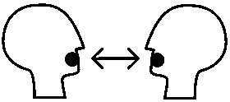



Listening |  |  |  |  |  | Reading |  |  |  |  |  | Spoken  Interaction |  |  |  |  |  | Spoken  Production |  |  |  |  |  | Writing
1 | 2 | 3 | 4 | 5 |  | 1 | 2 | 3 | 4 | 5 |  | 1 | 2 | 3 | 4 | 5 |  | 1 | 2 | 3 | 4 | 5 |  | 1 | 2 | 3 | 4 | 5

Part 2 – Experience and motivation
1 | Are you involved in work of any organization? | NO  YES (what?)
2 | Please describe your experience within media work? What skills do you have?
3 | What are your expectations regarding the training?
4 | What is your motivation to participate in the project?

Please send application to: Magdalena Gnyp m.gnyp@eds-fundacja.pl

