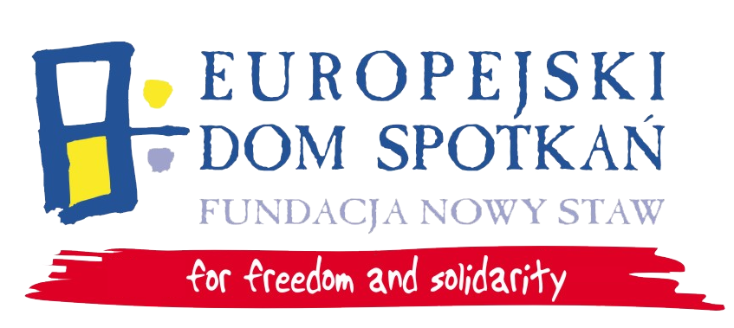


Youth In Action
4.3 - Multimeasure project
„Towards active participation”
PART II – Training course for youth leaders
“ACTING YOUTH”
3rd – 10th November
Nasutów near Lublin (POLAND)

PART 1 – Information on the applicant

A) Personal details

1 | First and last name:
2 | Date and place of birth:
3 | Country of residence:
4 | Profession/occupation:
5 | Special needs (e.g. vegetarian dishes etc.):
B) Contact details

1 | Address:
2 | E-mail address:
3 | Cell phone:
C) Language skills

Please mark your language skills of English according to 1=insufficient, 2=fair/quite good, 3=good, 4=very good, 5=excellent/native for the themes below.

  Listening |  |  |  |  |  |   Reading |  |  |  |  |  |   Spoken  Interaction |  |  |  |  |  | Spoken  Production |  |  |  |  |  |   Writing
1 | 2 | 3 | 4 | 5 |  | 1 | 2 | 3 | 4 | 5 |  | 1 | 2 | 3 | 4 | 5 |  | 1 | 2 | 3 | 4 | 5 |  | 1 | 2 | 3 | 4 | 5

Part 2 – Information on organization/institution

Organization’s contact details

1 | Name of the organization:
2 | Telephone:
3 | E-mail:
4 | Website:
Part 3 – Experience and motivation

1 | Are you involved in work of any organization? |  | NO  YES
2 | If yes, please give a short description of the organization/organizations.
3 | Please describe projects you participated (theme, goals, your role)
3 | What is your knowledge about “Youth in Action” Program? |  | I realized some projects within YiA  I didn’t realize any projects within YiA but I’ve heard about it  I have only knowledge but no experience  I have some experience without deep knowledge  I haven’t heard about YiA
4 | What is your motivation to attend this TC? What would you gain during training days? Please describe your expectations.

The deadline for applications: 14th October 2011

Contact person: Jacek Lis, j.lis@eds-fundacja.pl, 48 81 536 10 92

