Personal information  1. First name:  2. Family name:  Male Female  (double click on the box and choose: mark)  3. Country:  4. Date of Birth:  5. Organisation/institution:  6. Position/function:  7. Education:  8. Address for correspondence:  9. Telephone:  10. Mobile phone:  11. E-Mail:  12. Vegetarian (Yes/No): Yes No  13. Do you eat pork? (Yes/No): Yes No  14. Any other special needs:  15. Have you ever participate in project organised by European Youth4Media Network e.V.  Yes No  If yes, please specify: |  |   APPLICATION FORM  Train the Trainers  01–08.04.2009, Münster  Training course supported by the Youth in Action Programme and organised by the  European Youth4Media e.V.  Bennostrasse 5  48-155 Münster, Germany  Tel. +49 251 60 96 73  Fax +49 251 60 96 777  mail: team@ngotv.eu  (deadline 01.03.2009)  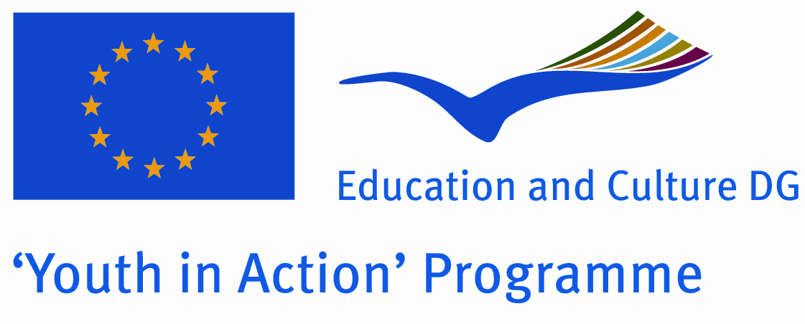

Passport information (ONLY FOR NON-EU COUNTRIES)

16. Do you need Schengen Visa? Yes No

17. Passport number:

18. Date of issue:

19. Date of expiry:

20. Country which issued the passport:

21. Please give a short description of your youth work and write down what is your motivation to take part in the training (up to 250 characters):

se giv

22. Please give a short description of the organisation you are active in. Is your organisation interested in joining European web TV project? (up to 250 characters):
23. Participation in training courses, seminars, etc.
Name and topic | Place | Period of time

24. Please indicate your knowledge of languages by marking (double click on the box) proper boxes below (1-elementary, 2-communicative, 3-advanced, 4-fluent, 5-native)
- English  - ………………  - …………….... | 1 2 3 4 5  1 2 3 4 5  1 2 3 4 5
25. How did you learn about Train the trainers training course? (e.g. poster, web, word of mouth...)

Please, send the filled out form to team@ngotv.eu (please change the name of the file to: familyname_firstname.doc according to the example: smith_john.doc)

Consent to processing participant’s personal data
Sending filled application form means agreement for:
- consent to processing participant’s personal data by the European Youth4Media Network e.V. as required by the recruiting process according to the German law on protection of personal data. Any time applicant has the right to inspect and change one’s data.
- receiving via Internet all information about the training courses from the European Youth4Media Network e.V. Any time applicant has a right to withdraw one’s consent to the agreement.

